Project Design Phase
Problem – Solution Fit

Date | 14 Feb 2026
Team ID | LTVIP2026TMIDS35994
Project Name | Househunt: finding your perfect rental home
Maximum Marks | 2 Marks

Problem:
Finding suitable rental houses is a major challenge for tenants, while property owners face difficulties in managing listings, verifying tenants, and handling bookings efficiently. Traditional methods such as brokers, classified ads, and manual communication are time-consuming, lack transparency, and often result in misinformation, delayed responses, and security concerns for both parties.

Solution:
The project “Rent Ease – House Rental Management System” provides a complete digital solution for the house rental process:
- A MERN-stack based web application with React.js frontend and Node.js–Express backend.
- Secure user authentication using JWT for renters, owners, and administrators.
- Property owners can add, update, and manage rental property listings with images.
- Renters can browse properties, view details, and place booking requests online.
- Admin panel to manage users, properties, and booking approvals.
- MongoDB database ensures reliable storage and retrieval of user, property, and booking data.

Outcome for Users:
- Renters: Easily search, view, and book rental properties without relying on brokers.
- Property Owners: Manage property listings and tenant requests efficiently through a single platform.
- Administrators: Monitor and control system activity, ensuring security and authenticity.
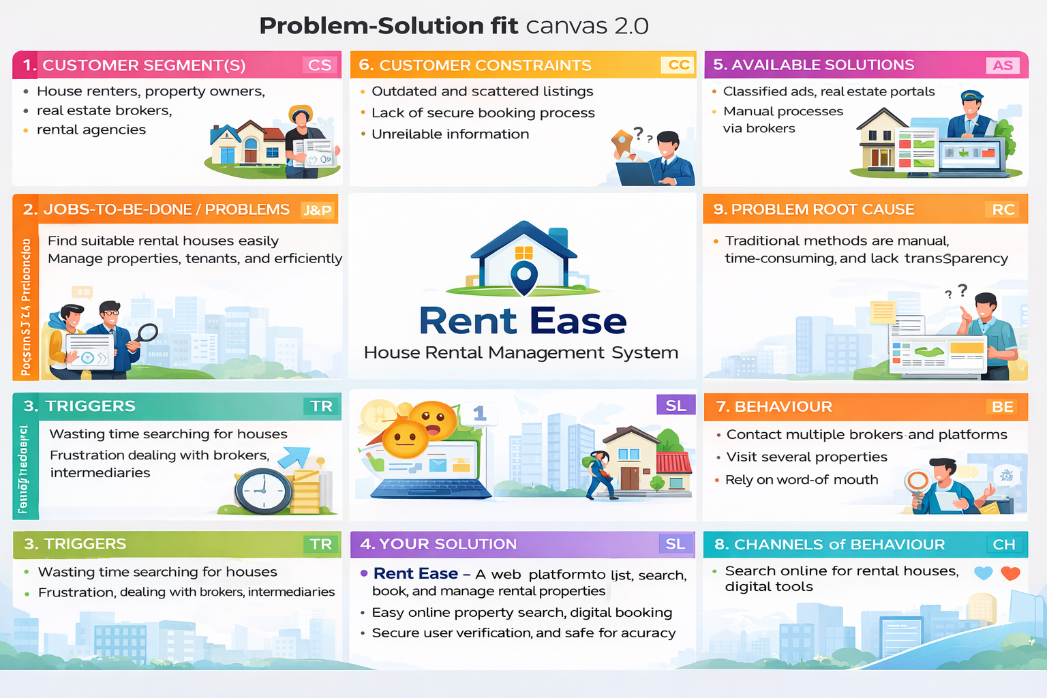
- Overall: Faster, transparent, and more reliable house rental experience.

Repository Resource:
🔗 https://github.com/JeevanKumar009/Enchanted-Wings-Marvels-of-Butterfly-Species-Project

